Myrtle Marie (Audiffred) Brady

March 29, 1918 – August 21, 2001

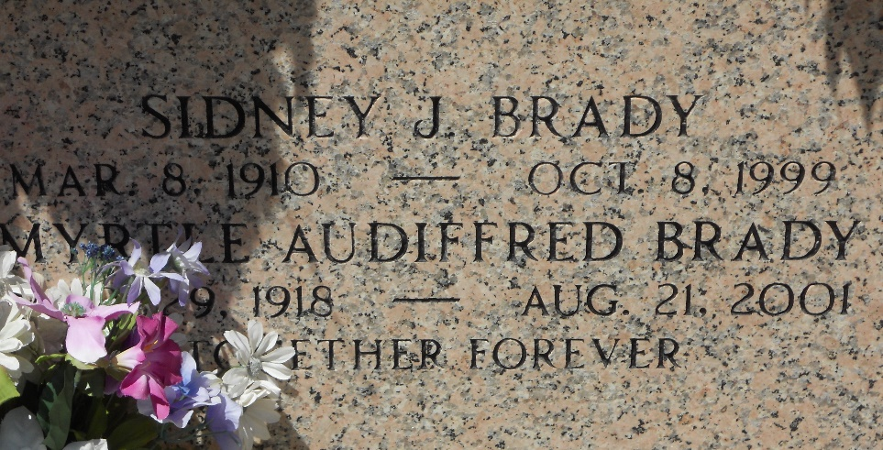

Photo by Team T-Lo

Age 83 years, a native of Reserve, Louisiana, and a resident of Laplace, Louisiana, for the past 55 years.

Wife of the late Sidney Brady and mother of Brynn Conrad and Sylvia Brady.

Services were Saturday 25 Aug 2001 at St Joan of Arc Church, Laplace, with interment in St Peter Cemetery, Reserve.

The Times-Picayune, New Orleans, Louisian

August 23, 2001